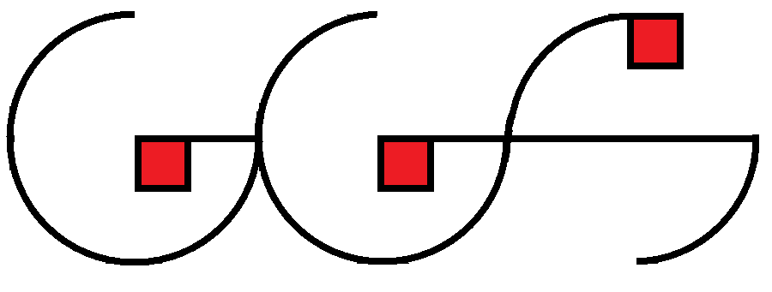
GRADITELJSKO GEODETSKA ŠKOLA OSIJEK
Osijek, Drinska 16a

BUS LINES

OSIJEK – BELGRADE
07:00 | 10:33 | 03:33 | 176 | PT-ČZT-Lasta-Šidexpres | Osijek-Beograd
10:00 | 13:33 | 03:33 | 176 | PT-ČZT-Lasta-Šidexpres | Osijek-Beograd
13:00 | 16:33 | 03:33 | 176 | PT-ČZT-Lasta-Šidexpres | Osijek-Beograd
17:00 | 20:53 | 03:53 | 176 | PT-ČZT-Lasta-Šidexpres | Osijek-Beograd

BELGRADE – OSIJEK
VERY IMPORTANT: Belgrade has 2 central bus stations. You are going on LASTA bus station (http://lasta.rs/). Please be carefully because the 2 central bus stations are close to each other!
You will pay the tickets in DINAR.
06:30 | 10:03 | 03:33 | 176 | PT-ČZT-Lasta-Šidexpres | Beograd-Osijek
10:00 | 13:33 | 03:33 | 176 | PT-ČZT-Lasta-Šidexpres | Beograd-Osijek
15:00 | 18:33 | 03:33 | 176 | PT-ČZT-Lasta-Šidexpres | Beograd-Osijek
18:00 | 21:33 | 03:33 | 176 | PT-ČZT-Lasta-Šidexpres | Beograd-Osijek

For more details:
http://www.panturist.hr/lines-timetables/timetables_pricelists/index.html
Return ticket: about 30.00 euro + 1 euro per person for entrance to station
Belgrade is a big city, be carefully about taxi…

From airport you have the public bus (300 DINARA), or by taxi – I suggest that you contact the taxi office inside of airport…

